GallOp System for HOOF, Inc.

**by Fine Equine**

Vision Document

Version 3.0

Revision History

|  |  |  |  |
| --- | --- | --- | --- |
| **Date** | **Version** | **Description** | **Author** |
| 23/Jan/18 | <1.0> | First Draft – Vision Document | Fine Equine Members |
| 12/Feb/18 | <2.0> | Second Draft - Vision Document | Fine Equine Members |
| 26/Feb/2018 | <3.0> | Third Draft - Vision Document | Fine Equine Members |
|  |  |  |  |

Table of Contents

1. Introduction 4

1.1 References 4

2. Positioning 4

2.1 Problem Statement 4

2.2 Product Position Statement 4

3. Stakeholder and User Descriptions 5

3.1 Stakeholder Summary 5

3.2 User Summary 6

3.3 User Environment 6

3.4 Summary of Key Stakeholder or User Needs 7

3.5 Alternatives and Competition 7

4. Product Overview 8

4.1 Product Perspective 8

4.2 Assumptions and Dependencies 8

5. Product Features 9

6. Other Product Requirements 9

7. Appendix Feasibility 10

Vision Document

# Introduction

The purpose of this document is to collect, analyze, and define high-level needs and features of the HOOF, Inc. GallOp System. It focuses on the capabilities needed by the stakeholders and the target users, and **why** these needs exist. The details of how the HOOF Inc. GallOp System fulfills these needs are detailed in the use-case and supplementary specifications.

**1.1 References**

Hoof KY - Strategic Assessment 4/19/2017 - Report 2

IT Strategic Assessment Report HOOF KY 4/20/17 - Report 4

Jacob Meyers Strategic Assessment 4/20/17 - Report 5

# Positioning

## 2.1 Problem Statement

HOOF, Inc. does not utilize a database for their business functions and to drive their website features which affects the non-profit, volunteers, and beneficiaries.The impact this has on the organization is a lack of data security, a lack of integration of data between members and a lessened ability to collect and analyze data directly from the organizations website. A successful solution would be to integrate existing technologies into the organization including a database that will facilitate their business processes, and a feature rich website that is secure, functional, and easy for the organization to use and maintain. The solution should be capable of being utilized from a cloud server and economically sustainable.

## 2.2 Product Position Statement

For Horses Offering Opportunities for the Future, Inc. who can benefit from the implementation of an organizational database to improve business processes, data sharing, and data security, The HOOF GallOp (Gather all Operations) System is a relational database system that will facilitate the collection and sharing of data between members of the organization and function with the HOOF website. It will also be secure and subject to regular backups to lessen the risk of data loss.

The current model has data stored on multiple personal computers and spreadsheets which poses the risk of data loss and compromises the security of private user information. The product envisioned by Fine Equine will centralize data that can be stored on a cloud platform with secure and easy access and management. The ultimate goal of our product is to save time and money for HOOF, Inc. and enhance their ability to raise funds. The system will allow for data to be easily shared amongst users with different access levels for security. The database will also support the features of the organization’s website allowing it to take on a higher level role than just a simple marketing tool.

# Stakeholder and User Descriptions

## 3.1 Stakeholder Summary

|  |  |  |
| --- | --- | --- |
| **Name** | **Description** | **Responsibilities** |
| Board of Directors | Comprised of volunteers who have devoted their energies to the goals of HOOF, Inc. | Business Planning  Securing donations  Grant writing  Fulfilling the goals of the organization  Monitoring the overall effectiveness of the organization |
| Volunteer Coordinator | A volunteer who facilitates the human resources aspects of HOOF. | Recruiting volunteer staff  Managing the needs of volunteers such as tracking and reporting volunteer hours if needed. |
| Auction Director | A volunteer who is in charge of the silent auction fundraiser for HOOF, Inc. | Managing the inventory of donated items.  Event coordination. |
| Director of Public Relations | A volunteer who is in charge of the public relations and marketing for HOOF | Press releases  Interacting with the media  Managing how the organization is perceived by the public. |
| Social Media Manager | A volunteer who manages the social media accounts for the organization | Create and maintain social media accounts  Create posts  Increase online visibility |
| Accounting /Bookkeeper | Manages the accounting duties of the | Performs financial functions for the organizations.  Collect and Input financial data.  Tracks the revenues and expenses of events. |
| System Administrator | A volunteer who will be tasked with learning and managing the information systems | Understand the database system in use  Understand the different software in use  Troubleshooting |
| Stable Holder | Owns the stable that HOOF activities are hosted | Provide a safe environment for the children for the children to enjoy their HOOF experience |
| Youth Participants | Disadvantaged youth from the community that are selected for the services offered by HOOF | Participate in HOOF activities  Learn and grow from the experience  Make the experience enjoyable for self and others |

## 

## 3.2 User Summary

|  |  |  |  |
| --- | --- | --- | --- |
| **Name** | **Description** | **Responsibilities** | **Stakeholder** |
| Board of Directors | Primary End User of the system whose activities encompass every aspect of the system | Coordinate work  Seek funding  Tracking donations  Collect and analyze data  Seek beneficiaries of HOOF services  Event coordination | Direct stakeholders represented by Dr. Suzanne Meeks |
| Auction Director | Primary End user of the system | Manage inventory  Publicize auction event  Coordinate event activities  Manage payment of auction items | Direct stakeholder |
| Volunteer Coordinator | Primary End user of the system | Manage volunteers  Recruit volunteers  Collect and report volunteer hours and tasks | Direct stakeholder |
| Accounting / Bookkeeper | Primary End user of the system | Collect payment data  Analyze data  Report data | Direct stakeholder |
| System administrator | System Administrator | Maintain/Troubleshoot/Support the system  Grant access and permissions  Learn the system | Direct stakeholder |

## 3.3 User Environment

As a non-profit organization, HOOF, Inc. primarily uses donations to fund the activities for the children. It does not have an office and members use personal laptops/PC’s and mobile devices to function. The organization currently uses Windows 10, Microsoft Office (Excel, Word, Outlook, etc.), Google Docs, and QuickBooks. Donated software and freeware are also used to keep the cost of operations low.

There are currently about 10 core volunteer board members who commit their time and energy to the organization in support of its mission goals. There are other volunteers that assist in the events and operations as well as a paid intern who assists with the bookkeeping. HOOF, Inc. would like to hire an Executive Director.

Donations are currently facilitated by PayPal as their payment system which allows donations to come in electronically. Donation data should be be able to be collected and stored to the database.

## 3.4 Summary of Key Stakeholder or User Needs

|  |  |  |  |  |  |
| --- | --- | --- | --- | --- | --- |
| **Need** | **Priority** | **Concerns** | **Current Solution** | **Proposed Solutions** | |
| Increase Donations | 1 | There are donations that HOOF is missing out on by not implementing better donation solicitation processes. | Paypal for electronic receipt of funds.  Checks are accepted.  Website Link does not work | | Implement a payment system that is easy to use, low cost and that allows donor tracking and recurring payments |
| Accounting costs | 2 | There is money being spent that could be saved with an appropriate solution. | Currently money is being spent to license QuickBooks, an accounting software. | | Transfer accounting data from QuickBooks to Excel spreadsheets and organize them into one organized, secure location. |
| Tracking time spent on various activities | 3 | A shared document lacks security. Users can edit all the information in the document. | Enter hours onto a shared Google Docs file | | Create a volunteer portal on the website that is password protected and allows volunteers to enter and track time spent on activities for only their username. |
| Tracking Donations | 1 | Missed opportunity to increase donations by improper donor tracking | Donations are tracked via a spreadsheet | | Create a donation database with tracking and contact information. With an optional mailing list the donors can be contacted about special events very easily. Donors are likely to repeat donations if they keep active in the organization. |

## 3.5 Alternatives and Competition

There are three alternative options for HOOF, Inc. as shown here:

* Continue with the status quo
* Choose from amongst the other five competing project groups from CIS-320 Spring 2018.
* Recruit volunteers with the talent, time, and will to implement a homegrown solution.
* Hire consultants at market value

HOOF, Inc. may choose to continue with the status quo with the sole benefit being that no additional effort would have been expended. However, choosing to continue with the status quo would be to ignore the problems the organization is facing. This is a weak alternative because some of the problems could prove to be disastrous such as the theft or loss of private data. The benefits of choosing Fine Equine’s product or the following two alternatives are greater than continuing with business as usual.

The competing groups bidding for the HOOF, Inc. project may provide similar ideas as Fine Equine. HOOF, Inc. benefits from this competitive bidding by having several options from a talented pool of technically capable students. At this time, the competition that Fine Equine faces is shrouded in secrecy making it difficult to gauge the strengths and weaknesses of their products.

The option of recruiting volunteers to develop a solution will take additional time and effort from HOOF Inc. with no guarantee of success. There may be a perception that a technically capable volunteer could complete this task, but the weakness to this option is that finding the right talent who is willing to volunteer for the project at no cost is unlikely. The additional difficulty is in finding a team to perform the work at no cost and hasten the implementation of the project.

The final option of hiring consultants has its merits to complete the project has its merits. The result may be a well-executed system in a timely manner, but is likely cost prohibitive to HOOF, Inc.

# Product Overview

## 4.1 Product Perspective

The envisioned product is to create an highly integrated system for HOOF’s business environment. The assumption is that the users will have web access and be able to perform several business processes directly from the HOOF website and interact with the website as needed to view and export data so it may be manipulated with Google Docs or Microsoft Office applications with ease. As HOOF does not have a formal office, the stakeholders will likely utilize laptops running on Windows operating systems moving forward. Information intended to be stored in the HOOF, Inc. database will be manipulated with Excel primarily.

It is currently understood that the stakeholders are highly talented professionals in their areas of expertise, but technology is not their primary focus. Therefore, user friendliness is a high priority to ensure that the system to be built has high utility.

It is crucial that the database be easily entered via forms, and easily exported as needed so it can be manipulated in a software environment the users are familiar with (ie. Microsoft Excel)

Additionally, once implemented, the amount of ongoing support for the system will be limited. As a non-profit organization, the amount of funds allocated to supporting the technology is severely limited. It will become increasingly important over time, that the system have a base level of documentation to pass forward to the systems administrators that are charged with the future success of the program.

## 4.2 Assumptions and Dependencies

The solution proposed by Fine Equine is intended to be minimally invasive to the current business environment. Dependencies are relatively low because HOOF is not tech heavy. Ideally, the system envisioned will require no additional software purchases. Consideration should still be given to the environment and the impact that changes will have on the vision. A successful implementation will be minimal in cost and allow seamless integration with current and future applications:

* QuickBooks
* Current browsers (Microsoft Edge, Google Chrome, Firefox)
* Microsoft Office
* Paypal or any proposed payment management system
* Any CRM to be considered

# Product Features

The content management system (CMS) tool will be implemented by U of L and will be used by HOOF members with administrative permissions. This tool allows members the benefits of editing and adding content, as well as making changes to the design of the website without the need of a professional developer. The CMS tool requires minimal effort to learn and will allow users to test their changes to the website in a testing environment first to maximize confidence. The CMS tool is vital to the creation of the website as well as the upkeep by HOOF members in the future. This places it at the highest level of priority.

The payment portal will allow for donations to be made in a larger variety of methods than now available on the website. Currently, only PayPal is allowed, which shuts out any donors willing to pay with a different payment method. Having a specialized payment portal adds extra security and assurance to donors which will also increase the likelihood that they will make a donation through the website. HOOF is a non-profit, so they rely on donations. This reliance prioritizes the payment portal being implemented at the highest level.

The centralized and secure database will allow for HOOF to thrive by maximizing efficiency through organization and an upgrade to multiple processes. Making sure that important data is secure and in one location minimizes the chances of losing data or sensitive data getting into the wrong hands. The security and efficiency of data access and use, places creating and securing a database at a high level of priority.

The website will be the heart of HOOF, allowing for their mission to be spread, volunteers to be recruited and donations to be received. The website will also serve as a portal, allowing access to the centralized database and the volunteers to a specialized portal that will allow them to track their hours and keep up with current events. The importance of the website and its functions places it at the highest level of priority.

The replacement of QuickBooks with Excel spreadsheets will allow for costs to be reduced. It will also allow for simpler upkeep, for members are more likely to be comfortable with Excel versus QuickBooks. The replacement of QuickBooks is important, but not going to impact donation revenue or increase skill sets. The role does not play a large part in business processes, but will result in HOOF’s favor, placing it at a medium level of priority.

# Other Product Requirements

Environmental requirements are the secure use of non-personal devices by administrative members. Currently personal devices are being used, resulting in inefficiency and lack of security. The performance requirements are not high at this point in time. WordPress will be able to handle the traffic to the site and the cloud base storage used will be able to adapt as storage needs grow. W3C standards will be followed when coding for the site.The constraints are set by the limited budget of the organization. They are dependent on outside donations and grants to operate and maintain business. This constraint has restricted us to open-source software.

WordPress documentation will be readily available, especially in the beginning stages of use. WordPress is extremely user friendly, but may still require further knowledge when it comes to doing tasks beyond simple editing of content. Online help will also be available. Installation should be fairly simple since we are just loading data to servers and building a lot of the site through WordPress.

The use of non personal devices and a secure, centralized database is top priority for efficiency and security reasons. Theres is no risk and effort will be minimal compared to the benefit. The utilization of a cloud server and WordPress is feasible, but not as stable as hosting our own server would be.

**7. Feasibility**

Technical feasibility looks at the capability of the organization to successfully develop the proposed system. Included in this assessment is the project size, the types of technologies to be used in the project, and the amount of prior experience with that technology and the business application. Our team consists of CIS students majoring in web development and information security. A few students have taken or are currently taking web development courses in C# and SQL database management. Therefore, the system process is familiar to us and we develop this using a combination of agile and waterfall methodologies. Our team is familiar with the technology as we have several student web developers on the team that will create the feature-rich website that HOOF needs. The students will be mentored under professors that have worked in the IT field for several years and will oversee the development project. The project is manageable in size and will have a team of six students working about twenty hours per week on the project and meeting weekly, ensuring the completion of the project within a reasonable time of fifteen weeks.

Economic feasibility addresses the economic justification of the project. Here, we attempt to determine if the value of the project's benefits justifies investing in the project's estimated costs. Currently, HOOF is barely making enough money to cover expenses, let alone camps. Their total expenses consists of insurance, office/administrative, website, and program costs totalling $17,386. HOOF’s income consists of donations, fundraisers, and foundation benefits plus the balance from the previous year, totalling $27,286. Including the grant they just received, this make their revenue $36,686. Of course there are intangible benefits that go along with these developmental changes including, but not limited to: more time for grant granting, increased number of camps held each year and therefore increase in attendance which means more happy kids reached. The kids get to spend more time with the horses, Hoof will have a more distinguished and well-known presence in the community which will also lead to an increase in volunteers as well as donors. Hoof will be using a Payment Portal which will cost 2.49% for VISA, Mastercard and Disc, 3.2% for AMEX, ACH .26 per transaction. They will be using the content management system WordPress. The only real cost is web hosting and domain, beginner users can get a domain name and web hosting for as low as $3.95/month from Bluehost or Siteground (both officially recommended WordPress hosting providers). Additional costs would be commercial WordPress themes. However, you are not required to use those. We also expect to see an increase in donations for HOOF, especially given since their donation link on their current website does not work. In our Optimist Forecast, we predict a 15% within the first year and then 8% each succeeding year. In 2016, HOOF received around $3,570 in donations. This means that in Year 1, that number will increase to $4,105 and then Year 2 will be $4,424 and by Year 5 it will be $5,585. In our Conservative Forecast, we predict a 10% within the first year and then 6% each succeeding year. This means that in Year 1, that number will still increase to $3,927 and then Year 2 will be $4,162 and by Year 5 it will be $4,958. According to the 2014 Charitable Giving by Source: Individual giving, $258.51 billion, increased 5.7 percent in current dollars (and 4.0 percent when inflation-adjusted) over 2013. Foundation giving, $53.97 billion, was 8.2 percent higher than 2013 (the increase was 6.5 percent when inflation-adjusted). For every 1,000 website visitors, a nonprofit raises $612.

Organizational feasibility evaluates whether the system is likely to be accepted and used by the organization. Included in this assessment will be the strength of the sponsor's and management's support for the project and the enthusiasm or resistance of the users for the project. Dr. Suzanne Meeks is the visionary and main audience for this project. She has the final say in all aspects. The Board of Directors will be using the website along with volunteers to do administrative tasks. Donors will also be using the new system, submitting donations via the website for HOOF. We would also like to integrate a form for local school, charities, and places for at-risk-youths to use the website to sign up the children for the camps.

**Optimist Forecast**

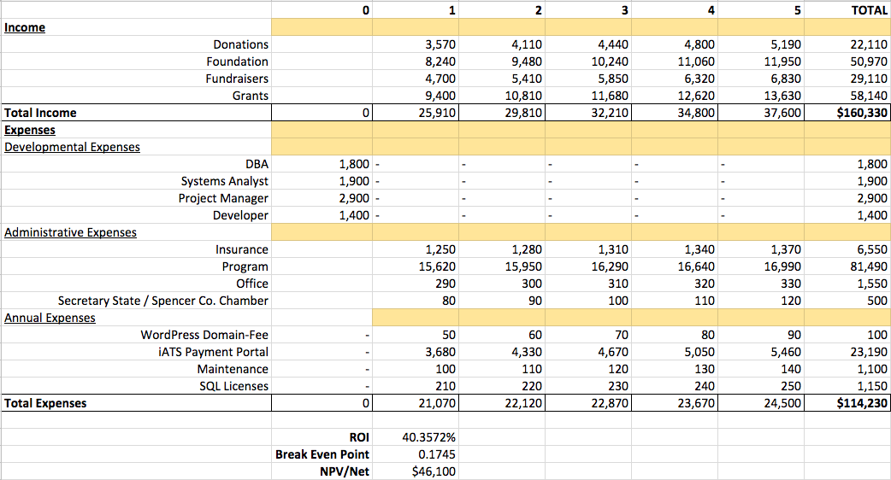

Income: This is our ***Optimistic Forecast*** for HOOF, KY. We predict the **donations** to increase by 15% within the first year, especially with a working link on the website, and then to increase by 8% each succeeding year. They received $3,570 in 2016, we hope to make this amount $4,110 within the first year and $6,260 by Year 5. The **Foundation** earned $8,240 in 2016. With a 10% increase in the first year, this amount will be $9,480 and this amount will have increased by 6% each succeeding year so by Year 5 it will be $6,260. We also hope to increase the amount collected at **Fundraisers** each year. In 2016 they accepted $4,700. With a 10% increase in the first year, this number could be $5,410 and by Year 5, $8,250. Furthermore, this forecast expects that HOOF will be able to write at least one more **grant** per year. Their one and only grant, obtained in 2017, equaled $9,400. By the second year they could write one for $10,810 and by Year 5, they could write one for $16,460. This amount could easily increase by the quantity of grants written each year.

Aggregate Income by year 5 is $174,910.

Expenses: **Developmental** Expenses include labor that will be donated by the University of Louisville Students. The job titles include DBA, Systems Analyst, Project Manager, and Developer. This would normally cost HOOF about $8,000 in total. However, this is considered a “gift” and therefore is not calculated into the total costs. **Administrative** fees include Insurance, Program, Office, and Secretary of State and Spencer County Chamber costs. Overall costing $17,240. Inflation does not take effect until Year 2, current inflation results to 2.1% as of January 2018. By Year 5, their Administrative costs will most likely result in $18,714. **Annual** Expenses include Domain and Website Hosting Fees plus any unexpected maintenance, grossing $150 in the first year but increase to $230 by Year 5 with current inflation of 2.1%.

Aggregate Expenses by year 5 is $91,040.

**Conservative Forecast**

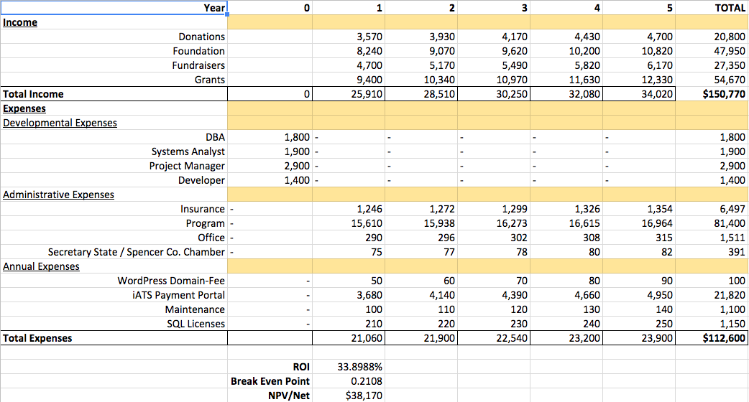

Income: This is our Conservative Forecast for HOOF, KY. We predict the **donations** to increase by 10% within the first year, especially with a working link on the website, and then to increase by 6% each succeeding year. They received $3,570 in 2016, we hope to make this amount $3,930 within the first year and $4,700 by Year 5. The **Foundation** earned $8,240 in 2016. With a 10% increase in the first year, this amount will be $9,070 and this amount will have increased by 6% each succeeding year so by Year 5 it will be $10,820. We also hope to increase the amount collected at **Fundraisers** each year. In 2016 they accepted $4,700 With a 10% increase in the first year, this number could be $5,170 and by Year 5, $6,170. Furthermore, this forecast expects that HOOF will be able to write at least one more **grant** per year. Their one and only grant, obtained in 2017, equaled $9,400. By the second year they could write one for $10,340 and by Year 5, they could write one for $12,330. This amount could easily increase by the quantity of grants written each year.

Aggregate Income by year 5 is $$150,770.

Expenses: **Developmental** Expenses include labor that will be donated by the University of Louisville Students. The job titles include DBA, Systems Analyst, Project Manager, and Developer. This would normally cost HOOF about $8,000 in total. However, this is considered a “gift” and therefore is not calculated into the total costs. **Administrative** fees include Insurance, Program, Office, and Secretary of State and Spencer County Chamber costs. Overall costing $17,240. Inflation does not take effect until Year 2, current inflation results to 2.1% as of January 2018. By Year 5, their Administrative costs will most likely result in $18,714. **Annual** Expenses include Domain and Website Hosting Fees plus any unexpected maintenance, grossing $150 in the first year but increase to $230 by Year 5 with current inflation of 2.1%.

Aggregate Expenses by year 5 is $115,900.